LNA Housing Update June 2022
Prepared by Sarah Linnes-Robinson, Acting Director
Note new information for each item is highlighted.

Kmart (Lake & Nicollet): The coalition of neighborhood associations and lead partner NEOO were selected to receive the $175,000 community engagement funding for the Kmart site! We are currently signing a contract with NEOO and providing proof of insurance to host community engagement events. We are working with NEOO and Whittier on compiling all the community engagement related to Kmart and Nicollet Avenue done in the last 50 years (or not done, as is probably the case for why Kmart was built where it was, and the highway too, for that matter).

PPL and Wells Fargo (31st & Nicollet): Start of construction is still planned for fall 2023. LNA received funding from the City’s Great Street program to highlight Nicollet Avenue and bring vibrancy and attention to businesses along the street in preparation for Nicollet opening. We are working with Wells Fargo to plan an event on their site (mini-grants will be given to various businesses for them to plan and execute their own events, where LNA serves as a partner and co-host) to highlight the new business that will be coming (including Afro Deli!) for this summer. We are expecting to hold this event in September, as businesses will first be meeting each other in July.

Twisted Hair (34th & Nicollet): This site will also receive funding from LNA as part of the City’s Great Street program (see details of this program in the paragraph above). We will be contracting with a Somali artist to work with Somali youth to repaint the defaced Walldogs mural which was temporarily covered with the water protectors mural. The multi-day event will take place the second week of August, probably the 10-13th with a loose plan for a community celebration on the afternoon-evening of the 13th.

The first Nicollet Pop-off event is being held on:
Nicollet Pop-Off Event #1: Water Works @ 37th, June 8 5:30-7:30 PM, Hosted by Butter Bakery Café
Come enjoy a taste of Butter and Area 51, PorchFest Preview Band ,while you learn about water conservation techniques utilized at both the hosting businesses. Celebrate water and learn alongside neighbors.

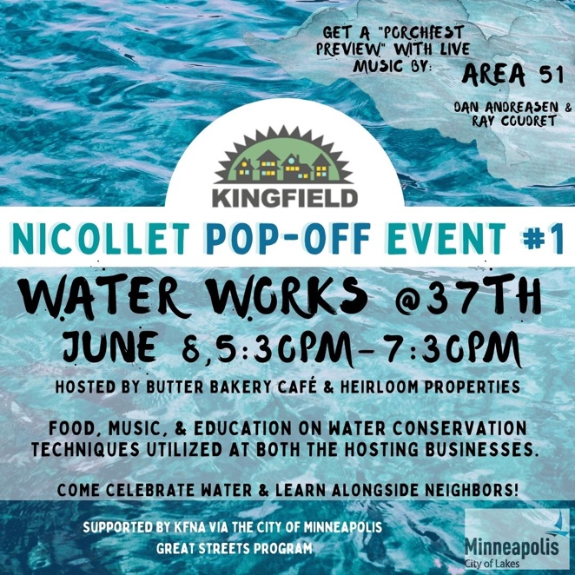

Alliance Housing Update (33rd & Nicollet): No Change: Still planning on opening somewhere between October 2022 and January 2023. “Teaching spaces” designed as part of this building are small and present a number of hurdles for their use as teaching spaces. Nicki Olalde, Education Program Manager will be designing a program to use these spaces that addresses the hurdles of space, security, storage, and marketing. She will be responsible for finding funding to start this program by the time the building opens.

Burger King (34th & Nicollet): no news

Ramen Kazama: An architect contacted LNA last week with a plan to design and build a two-story building in the parking lot south of the wings shop. It will be commercial below and two apartments above. He is working with Mathew Kazama, the property owner and Mathew’s business partner who I think he said is Basim Sabri (but I need to verify that is the co-owner.) We are working on a time for them to present their plans to the Housing committee (either June 1 at the meeting or a special meeting in July). Mathew also had a lot of questions about Kmart, Nicollet Open Streets, Nicollet, Burger King, and wants to get more involved. We are talking about collaborating on the Pop-off event at 34th with him.

South Nicollet Action Center (3537 Nicollet): We were granted the parklet for Nicollet in front of the office for the summer but have had to turn it down as the construction is too crazy and the trucks block the street all the time. We are still working on clearing the interior and are planning on official opening celebration for the fall.

3536 Nicollet: No Change: Lane closures and traffic flows will be affected for the length of the project. More significant closures and traffic obstructions will also happen throughout the duration of the project. Schedules constantly shift since so much (activity, weather, workforce, material availability) changes daily! Please let us know if you are hearing anything from our neighbors. If there are problems, we will react as quickly as we can. Please let me know if there’s any more information that we can provide at this time.

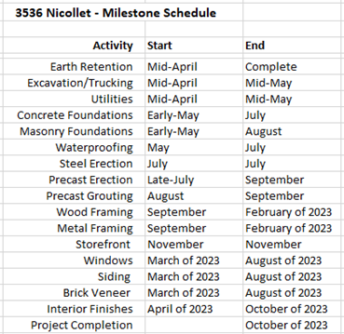

Lyndale Open Streets, June 5, 11 AM- 4:30 PM!
LNA is working to enliven the intersections of 33rd & 34th and will have staff and/or volunteers at the intersection all day. Twin Town will have live music and we are working on coffee on the street (from Five Watt), ice cream on the street (from Sonny’s), and a couple additional food trucks on the stretch. Also we are working with the new park director and the park planner to highlight the park reconstruction and are hoping to bring the 3rd Lair skate competition to the area. Volunteer for a shift here!

Zion Church: No Change: Zion is closing their church and selling their site and LNA has been in multiple conversations with them, and with potential partners about what a future grouping of buildings and uses at this intersection could look like. As talks progress, this is a project that the LNA Housing Committee should become deeply involved in.

LNA Housing Loan Program Updates:

There are no loan programs that are still active, but LNA does continue to get a bit of program income from loans made through some older programs that are now closed out (the programs not the loans).

Lyndale has four outstanding revolving loans and one outstanding deferred loan.

The four revolving loans have a combined balance of $18,065. Two mature in 2024 and one each matures in 2025 and 2028. The average amount returned to the Lyndale plan over the last couple of months has been a little over $500 per month.

The deferred loan has a balance of $2,097 and matures in 2027.

The $13,700 that you all returned last November, still sits (at the City) in the Develop Housing strategy. I have notes that you all were going to do a plan mod on those funds to move them into admin, but I think you put a kibosh on that plan. But they're still available to contract through that strategy or to reallocate to another strategy and contract them through there.

Park Dedication Fee Information:
Here is what I remember, but to verify the fact you could watch this video and here is the link to the meeting last fall regarding this matter: https://youtu.be/G1ROw1Huw_I
- Lyndale had a big chunk of Park Dedication dollars but they were used in the budget for the current reconstruction of Painter Park.
- It is not the neighborhood’s choice when and how these funds are taken and used. But we can track the money (and should) and suggest projects the community is interested in.)
- It is likely they are eyeing new park dedication fees in Lyndale for the splash pad construction and the Lyndale school poll decommissioning slotted for 2025 (my notes say this date, but I remember it being much farther out than this.)
- I do not know the plans for the old poll once it is decommissioned, including who will own the land.
- Affordable housing projects do not pay park dedication fees so much of the new housing being built will not add to these funds.
- Most of the units in the Hall Sweeny property coming in across from the office will contribute to this fund.
- It is a flat amount of money per unit and will result in (off the top of my head) somewhere between $200,000 -$300,000.

Committee Actions:
- Finalize Workplan
- Do we have a final answer to these questions yet?
  - How to best stay involved in key projects (direct project reps? Committee narrowing scope and all committing to a single project for the year?)
  - How to best stay informed of ongoing projects (LNA staff is not available to attend or lead committee meetings. What is the role of the committee? How do volunteers and staff best communicate? What projects do volunteers lead and which do staff lead? How do we handle as an organization new or emerging community development issues?)

